Griffin Rzonca

ECE 445

10/26/23

ESP32 Notes

**Things we need:**

* Ultimately need 3.3V power, a way to program the ESP32, and then to wire 8 of the ESP32’s GPIO pins to the AD9850
* USB/UART Bridge
  + [MCP2200-E/SS Microchip Technology | Mouser](https://www.mouser.com/ProductDetail/Microchip-Technology/MCP2200-E-SS?qs=W%2FMpXkg%252BdQ4tQo7NYLK%2FfA%3D%3D)
  + [Amazon.com: HiLetgo CP2102 USB 2.0 to TTL Module Serial Converter Adapter Module USB to TTL Downloader with Jumper Wires : Electronics](https://www.amazon.com/HiLetgo-CP2102-Converter-Adapter-Downloader/dp/B00LODGRV8/ref=asc_df_B00LODGRV8/?tag=hyprod-20&linkCode=df0&hvadid=563602091749&hvpos=&hvnetw=g&hvrand=14257303022916701787&hvpone=&hvptwo=&hvqmt=&hvdev=c&hvdvcmdl=&hvlocint=&hvlocphy=9022196&hvtargid=pla-576277438732&psc=1)
* 5V to 3.3V Voltage Regulator
  + [LP5907MFX-3.3/NOPB Texas Instruments | Integrated Circuits (ICs) | DigiKey](https://www.digikey.com/en/products/detail/texas-instruments/LP5907MFX-3.3%2FNOPB/5034443?utm_adgroup=General&utm_source=google&utm_medium=cpc&utm_campaign=PMax%20Shopping_Product_Zombie%20SKUs&utm_term=&utm_content=General&utm_id=go_cmp-17815035045_adg-_ad-__dev-c_ext-_prd-5034443_sig-Cj0KCQjw4vKpBhCZARIsAOKHoWRPjpJCVNpZnKMrKrl7gTXuqK5DchauH30TFv9LiBQoQ8M7wZmHj8YaAvPmEALw_wcB&gclid=Cj0KCQjw4vKpBhCZARIsAOKHoWRPjpJCVNpZnKMrKrl7gTXuqK5DchauH30TFv9LiBQoQ8M7wZmHj8YaAvPmEALw_wcB)
* Check those components to see if they’re good

**Implementation Notes:**

* Can NOT use a devkit in the final project, use the WROOM chip
* [:: ECE 445 - Senior Design Laboratory (illinois.edu)](https://courses.engr.illinois.edu/ece445/wiki/#/esp32_example/index)
* Can uses bare minimum schematic on course site:

**Notes on the ESP 32 Itself:**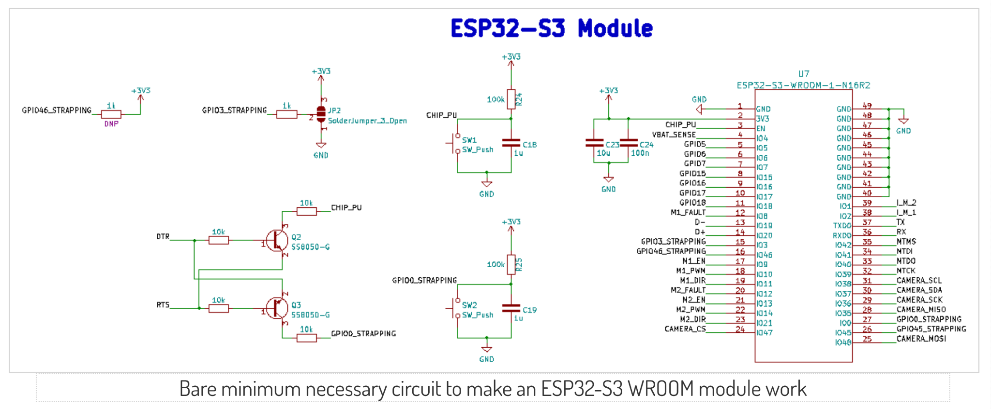

* Intro: [Getting Started with the ESP32 Development Board | Random Nerd Tutorials](https://randomnerdtutorials.com/getting-started-with-esp32/)
  + Has tutorial on how to load Arduino IDE onto ESP32
* Needs 3.3V logic, use voltage regulator
* Has wifi, bluetooth connectivity
* Dual-core processor (faster and uses less power than single core)
* Has DAC, UART
* Can program using Arduino IDE!
* We may need a USB to UART bridge
* May need the I/O part from the example board too so we can program the ESP32, since the TX, RX pins to connect come from the I/O section

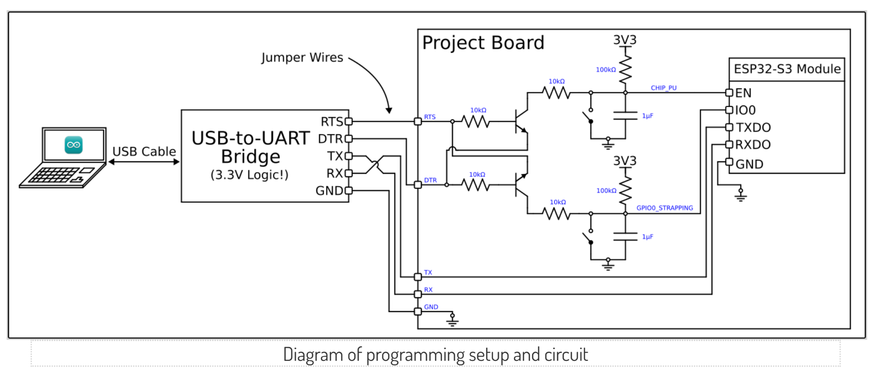

**Things to read more about:**

* What is the 8-bit word we need to generate 350kHz?
* Look into serial input for AD9850

**The Plan:**

* Buy a USB-UART Bridge
* Create jumper points from I/O section to send TX, RX, etc to ESP32
* Use bare minimum schematic with the I/O pins for TX, Rx, section
* Program using Arduino IDE
* Get 3.3V logic using a 5V wall wart with a 3.3V regulator, can use the 5V wall wart to power the isolation devices, op-amps, whatever else needs 5V